**Deliverable B: Discuss the data and its relationship to social conversation drivers**

Tweeter and Facebook are the main source of social media which connects billions. As of now, these two deliver almost the sentiments and opinions of the customers who can use Internet and are active at social networking and post comments on their purchases, comments and praises.

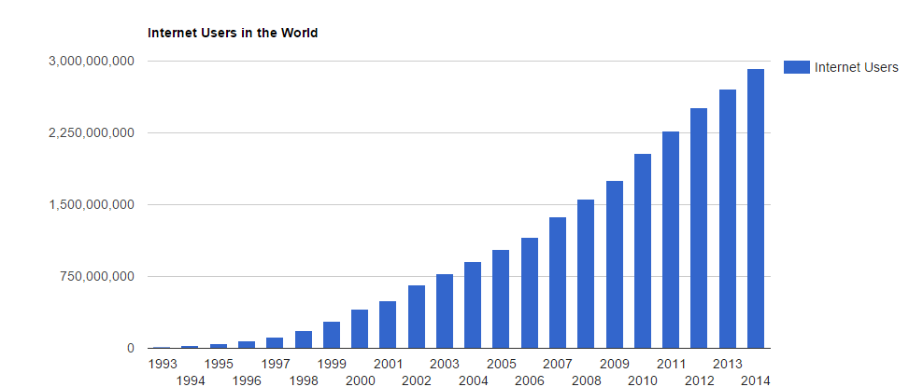

With the growing popularity of Facebook and tweeter, the number of active internet users increase day by day.

To get connected with the customers every enterprise tends to get Tweeter and Facebook account.

Hence, the data obtained from here is very important in determining the sentiment of the comments.

***How this happens***

Most of the transactions are online and most of the users open multiple browsers while working, At lease one of these would be a social networking site whose posts reflect the mood of the customer. Even if this assumption goes wrong, Customers are always connected to Facebook and twitter apps(Apps infact are the major and growing source of customers for facebook) .

Consider a case of a customer getting disappointed on “bank A”. That person would just switch his browser to the social networking site and post a complain redirecting to the ID of “bank A” or post a hatred message on facebook in the bank A’s page. This is the easiest and fastest way of reaching to the company(bank A). Customers who may contact the bank A’s customer care center would also post on social networking. This not only gives feedback on the bank A but also on its customer care. Most of the issues can be divided into credit card related, savings account related and customer care related.

Other posts to be observed include praises for sponsorships, posts regarding interview calls, etc.